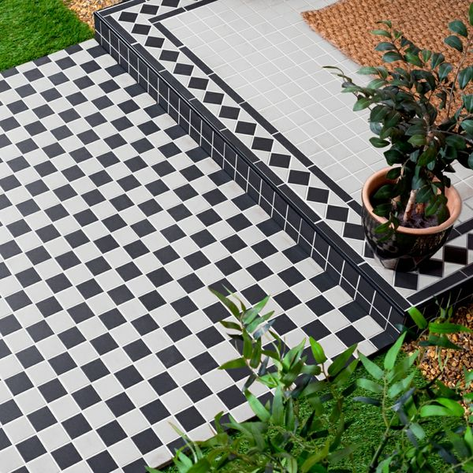**Churchill Snow & Midnight Chequer Mosaic Tiles:**

## **Product Description**

Black and white chequered floor tiles are the original decorative statement. Use these Churchill Snow & Midnight Chequer Mosaic Tiles to create a room-stealing period feature floor in your bathroom, hallway, lounge or kitchen! Because they're made from durable porcelain, they can even be used in the garden to create a patio space.

**What's special about these tiles?**

> Sought after Victorian style

> Made from sturdy porcelain

> Grippy R11 finish

> Perfect for use inside and outside

**The measure-up**

The individual tiles measure 45x45mm. There are 36 tiles per sheet and 11.82 sheets per sqm.

**Top tip: Seal before grouting**

Once the tiles are laid we recommend using the [LTP Porcelain Tile Protector](https://www.wallsandfloors.co.uk/ltp-porcelain-tile-protector) before grouting for the best finish.

## **Product Info**

* Product ID: 41056
* Tiles Per SQM: 11.80902445649
* Sale by: Per Sheet
* Size: 291x291x6mm
* Weight: 1.00 KG
* Material Type: Porcelain
* Finish: Matt
* Colour: Black and White
* Suitability: Floors, Walls
* Area Of Usage: External
* Grade: 5
* Rectified Edge: No
* Underfloor Heating: Yes
* Anti Slip Grade: R11 / 12 Degrees
* Thickness (mm): 6